First Blog Post Title - **The Red Carpet**

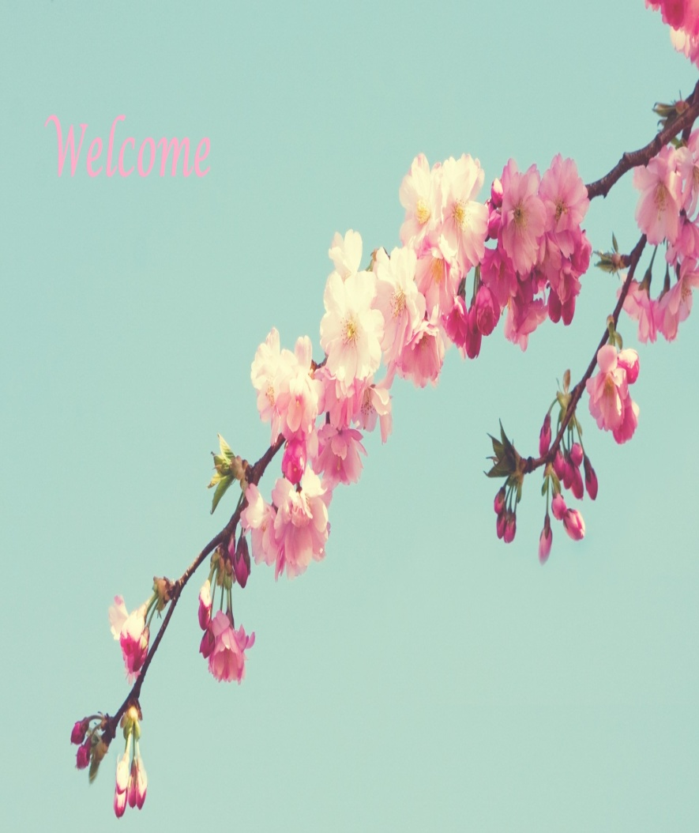

Here I am, following up on my hope and envision of writing and starting my blog about the strong beliefs that I have personally seen nurturing into fact. ***As I am, a happy person and a creative individual with a purpose to providing succour /aid to humanity by spreading awareness about the importance of investing for self impact and living a life full of happiness. The beautiful feeling of having a happy home in this real world inspired me to create another happy home in this virtual world as well***. Not only does the new home make me happy, but I am also very happy to welcome you in my newly built home. Hopeful to serve you as a feel at home guest, as you’ll experience little bit of happiness every time you come and visit my home. ***The basis of my work is Imaginative*** – as to relate to nature, ***Intelligent*** – as to show the difference in ordinary and excellent, also ***Inspiring*** – everyone with my work***. I believe that not living in a personalized happy home can lead to lack of positivity, lack of healthy enriching aura, lack of passion and motivation to live resulting in unhealthy relationships and depressed*** ***environment.*** So, welcome aboard to solving this life’s puzzle to create a happy aura home and be my recurring guest to ***create a crisp home where you belong!***

Second Blog Post Title – **Life With A Smile**

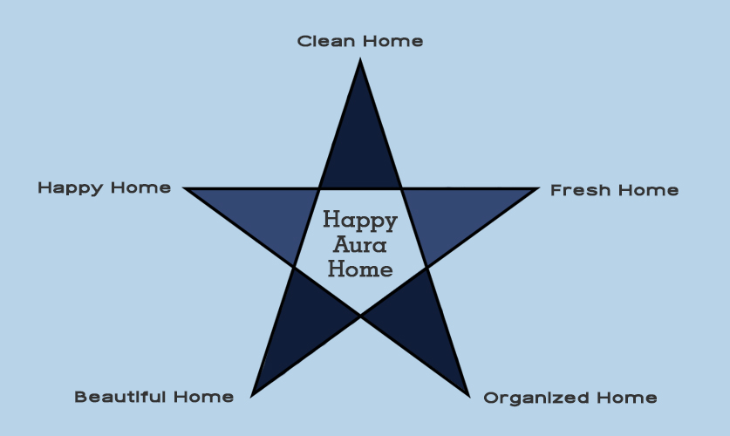

Gorillas burp when they are happy. Let’s hope you are burping everyday of your life.

A smile is happiness you'll find right under your nose. --- Tom Wilson

Imagine, the feeling you get when you are well dressed for an occasion that leaves you happy inside out. ***Similarly, making an effort to be happy inside out always, by living in a well-dressed home.*** And of course maintaining that look n feel and that happy attitude. Believing in this theory personally followed it by maintaining the link between the body, mind & space through various stages of life and time. Being in the state of complete happiness or blissfulness is like putting all the pieces of life’s puzzle together, first!

Life of happiness is a life full of satisfaction, clean fresh environment, healthy & happy relationship in a home. This is as simple as following a simple process of joining the dots to reach a desirable state. ***This state of being happy provides many additional benefits and achievements in all aspects of life, like professional, personal and worldly. The fact that small things make-up to the biggest of change also small bits of happiness and satisfaction adds-up to a life full of happiness.***

Statistic shows “HAPPINESS LENGTHENS OUR LIVES “According to scientists, happiness is a combination of how satisfied you are with your life overall, and how good you feel on a day-to-day basis.

***I believe, living in a beautiful aura of a house adds-up to a lot of satisfaction and a beautiful positive feeling every day. Happiness is a talent, that one can improve with practice inclusive of ability to manage your space. A very important piece of the life puzzle is the house we live in.*** For instances go from a clean home to a fresh home by adding a mild or strong fragrance of nature like essential oils on pine cloves, sanitizing carpets, baking soda & green tea jars or oranges and cinnamon in water of fresh flowers. From fresh homes to organized homes by stacking-up family of things together. ***Leading your way ahead to making a beautiful home with the help of a professional that shows the pathway to stylish living in all possible budgets and to lead your way to creating a crisp home where you belong to feel blissful living in a happy aura and cherish memorable moments with a Smile.***

Sharing with you my journey from clean, fresh home to organized beautiful home to a happy home and then managing it by joining together all the dots to create a happy aura of my home, that leads our way to putting in place ***another essential piece of this life’s puzzle of*** ***Enriching Healthy Relationships***. So, here we are ***living a life with a smile every morning and night in a home that fills us with positive vibes*** and helps put together the remaining pieces of the puzzle.